User Guide
Boolean Battles is designed to have an easy to use interface, with instructions being provided during the first level. We found that a tutorial during this level was the easiest way to simultaneously explain the game and perform the first level. The instructions are provided in the form of enemy dialogues.
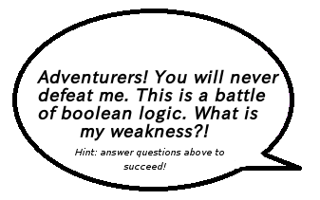

Fig. Example of a dialogue used as part of the tutorial
Players are tasked with defeating a series of enemies which stand in their way of reaching the Promised Land. The player has an initial health of three, and is reduced by one upon input of a wrong answer. The enemy health corresponds to the number of solutions available. All solutions must be given in order to defeat each enemy.
Attacks are in the form of bolts of elements:

Fire


Ice
Lightning

A neutral attack is shown with no colour, which results when none of the options of elements selected is chosen as a solution.
The questions relate to Boolean Logic, where the weakness of the monster is governed by the equations. For example:

Fig. Example of a question which corresponds to the weakness of an enemy. In this example, the weakness can only be both Fire and Ice.
The answer can be selected by toggling element buttons on or off. When ready to attack, the sword can be pressed which commences battle. If the answer is correct, the hero attacks in the form of animated bolts of the selected elements. However, upon entry of a wrong answer, they are rebounded upon the hero, taking damage in the process. If player health reaches zero, the game is ended.
Upon defeating an enemy, the hero is guided onto the next level where a different enemy resides. With an integrated map version, upon defeating an enemy, the user would be guided back to the map, where the next level becomes unlocked and can be selected. Previous levels can also be repeated with this version.

